
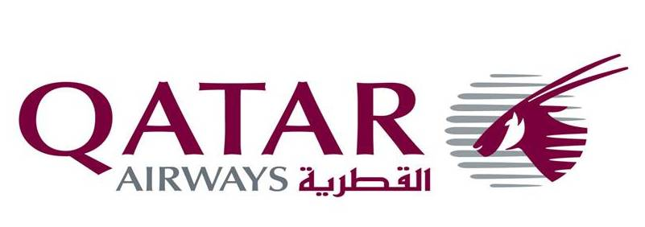

Please attach your photo
here.
空中乘务员职位申请表格

基本信息 | 姓名 |  |  | 户口所在地
基本信息 | 身份证号 |  |  | 所学专业
基本信息 | 性别 | 生日 |  | 最高学历
基本信息 | 电子邮箱 |  |  | 政治面目
基本信息 | 护照号 |  |  | 护照有效期
基本信息 | 目前居住城市及地址 |  |  | 矫正视力
基本信息 |  |  |  | 身高（米）
基本信息 |  |  |  | 体重（千克）
基本信息 | 户口所在城市及地址（如果与上面不同） |  |  | 手机
基本信息 | 母亲户口所在地地址 |  |  | 家庭电话
基本信息 | 父亲户口所在地地址 |  |  | 婚姻状况
教育背景 | 学校名称 |  | 在校时间 |  | 是否已获得毕业证书
教育背景 |  |  | 自年月 | 到年月
教育背景 |  |  |  |  | 是 □ 否 □
教育背景 |  |  |  |  | 是 □ 否 □
教育背景 |  |  |  |  | 是 □ 否 □
外语水平 | 语言 | 证书等级 |  |  | 获得时间
工作背景 | 公司名称 |  | 工作时间 |  | 职位 |  | 薪水
工作背景 |  |  | 开始年月 | 结束年月
档案情况 | 档案所在机构 |  |  | 负责人姓名 |  | 负责人电话
本人声明，以上内容全部真实有效。如果虚假，本人将承担一切后果。

申请人签名： 填表时间：

Please attach your photo here

Application for Cabin Crew Employment

Use block letters to fill all blanks. Where appropriate, please state ‘NA’ or ‘Nil’

PERSONAL INFORMATION

Family Name: |  | First Name: | English Name (If applicable)
Address: |  |  | Gender: Male/Female
Date of Birth | Nationality |  | Place of Birth
Passport No. | Age |  | Marital Status: Single  Married/Divorced/Widower
Height | Weight |  | Marital Status: Single  Married/Divorced/Widower
Mobile Phone | Home Telephone |  | Email:

LANGUAGE PROFICIENCY (indicate G: Good; F: Fair; L: Little)

Language | Spoken | Reading | Written
Mandarin
English

EDUCATIONAL QUALIFICATIONS
Highest Qualification:

From(m/y) | To (m/y) | Name of School | Major | Degree

EMPLOYMENT HISTORY

From(mm/yy) |  | To (mm/yy) | Name of Company | Position | Salary
Job Description:
Job Description:
Job Description:

Identification Mark

Type | Do you have any identification mark showed in the list? | Do you consent to indentifying their location to recruiters?
Tattoo | □ Y □ N | □ Y □ N
Scar | □ Y □ N | □ Y □ N
Birth Mark | □ Y □ N | □ Y □ N

I hereby declare that all information given herein is true and correct. I understand that a misrepresentation or omission of facts will be sufficient cause of cancellation for employment or dismissal from the Company’s service if I have been employed.

Signature/Date

